
Year 8

Term 1 Test 2019

Resources allowed: Calculator and a handwritten A4 notes page double sided

Name: ______________________ Class: ______ Time: 50 minutes Mark:_____/46

CALCULATOR FREE
20 minutes
Mark:____/20
- [6 marks]
Fill in the missing number in each of the following
a) $4+\left(-7\right)=____$ b) $-3-\left(-2\right)=____$

c) $\left(-4\right)×\left(-8\right)=____$ d) $-16÷8=____$

e) $\left(-4\right)×3+5=$___ f) $-12-5×4=______$

- [1, 1, 1, 1 = 4 marks]
Evaluate the following expressions, writing your answers as basic numerals (numbers):

- $3^{0}$
- $2^{5}$

- [1, 1, 1 = 3 marks]
Write the complementary event for the following:

- It will snow today

- Rolling a 6-sided die and getting a 4

- You ride your bike home

- [1, 1, 1, 2, 2 = 7marks]
Express the following in simplest index form using the index laws

- (7³) ³ b) $\frac{5^{7}}{5^{2}}$

- 4³ × 4⁴ d) $\frac{6^{4}×6^{7}}{6^{5}}$
- R

- $\frac{{\left(5^{4}\right)}^{3}}{5^{9}}$

Section 2: Calculator Assumed
30 minutes
Mark:____/26

- [3 marks]
Complete the following conversions:

- 37cm = ___________m

- 63700m = ___________km

- 7cm² = ___________mm²

- [1, 1 = 2 marks]
The perimeter of a rectangle is 42 m.

- Draw a rectangle with this perimeter and mark in a possible length and width.

- Find the area of your rectangle.

- [1, 1, 1, + 1 mark for all units = 4 marks]

Find the perimeter of the following shapes. Show your working clearly and giving your answers correct to two decimal places when necessary:
Shape | Working and Answer
a)
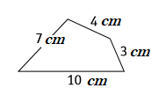

b)
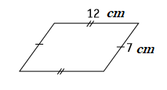

c)
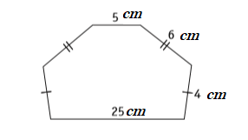

- [1, 2, 1 = 4 marks]
Find the area of the following shapes. Show your working clearly and give your answers correct to two decimal places when necessary.
Shape | Working and Answer
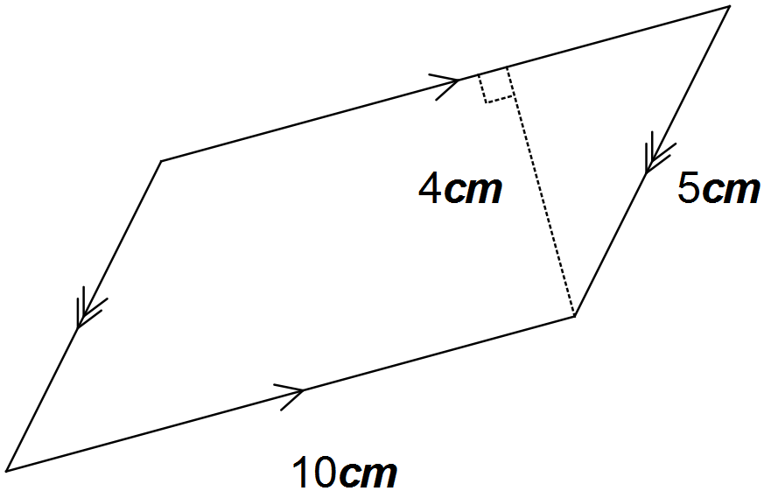a)

b)
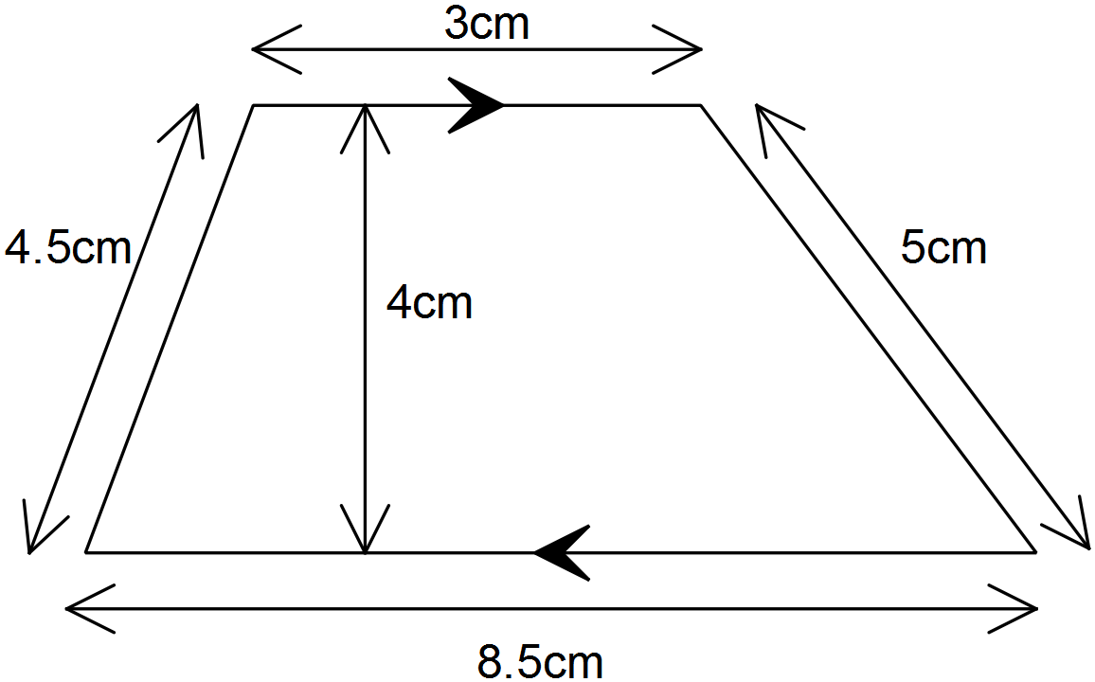

c)
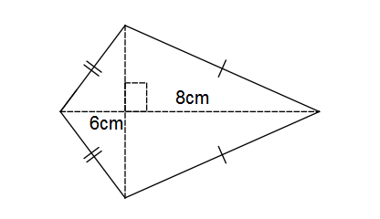

- [2 marks]
The area of a rectangle is 39$cm^{2}$. If the length of the longest side is 13cm, what is the length of the shorter side of the rectangle?

- [2, 2 = 4 Marks]
Calculate the volume of this prism:
Shape | Working and Answer
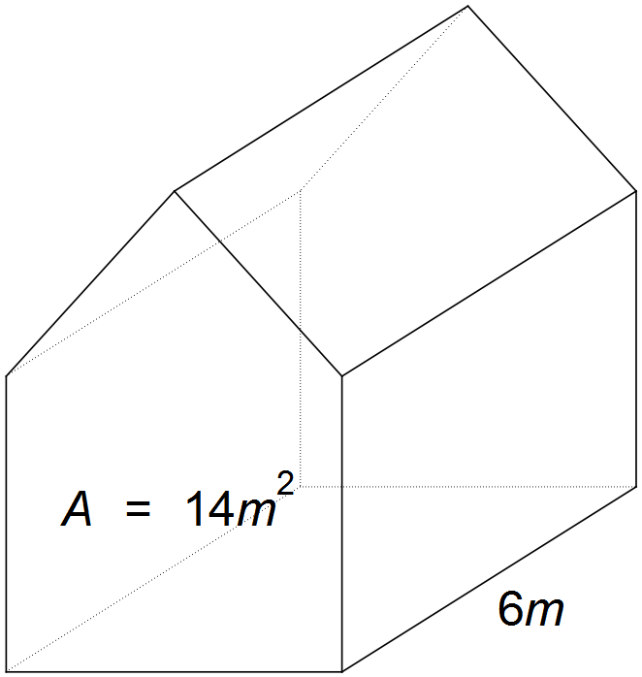

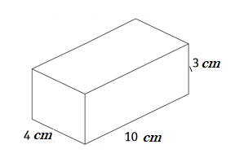

- [3 marks]
There are 10 counters in a bag. The counters are numbered 1, 2, 3, 4, 5, 6, 7, 8, 9, 10.
If one counter is drawn out at random, what is the probability that it is a counter:

- with an odd number

- that is greater than 6

- that is not greater than 6

- [2 mark]
- If the probability of selecting a blue marble from a bag of marbles is 0.3. Find P (Not Blue)

- If the probability of not selecting a red marble from a bag of marbles is $5/11$. Find P(Red)

- [1, 1 = 2 marks]
If we write the letters from the word MATHEMATICS on separate pieces of paper and place them in a bag, the probability of selecting an M is: P(M) = $\frac{2}{11}$.

a) Write down a word which has P(S) = $\frac{1}{4}$.

b) Write down a word which has P(vowel) > P(consonant).

End of Test

